**AUTOMATIC TAGGING OF MARATHON RUNNERS**

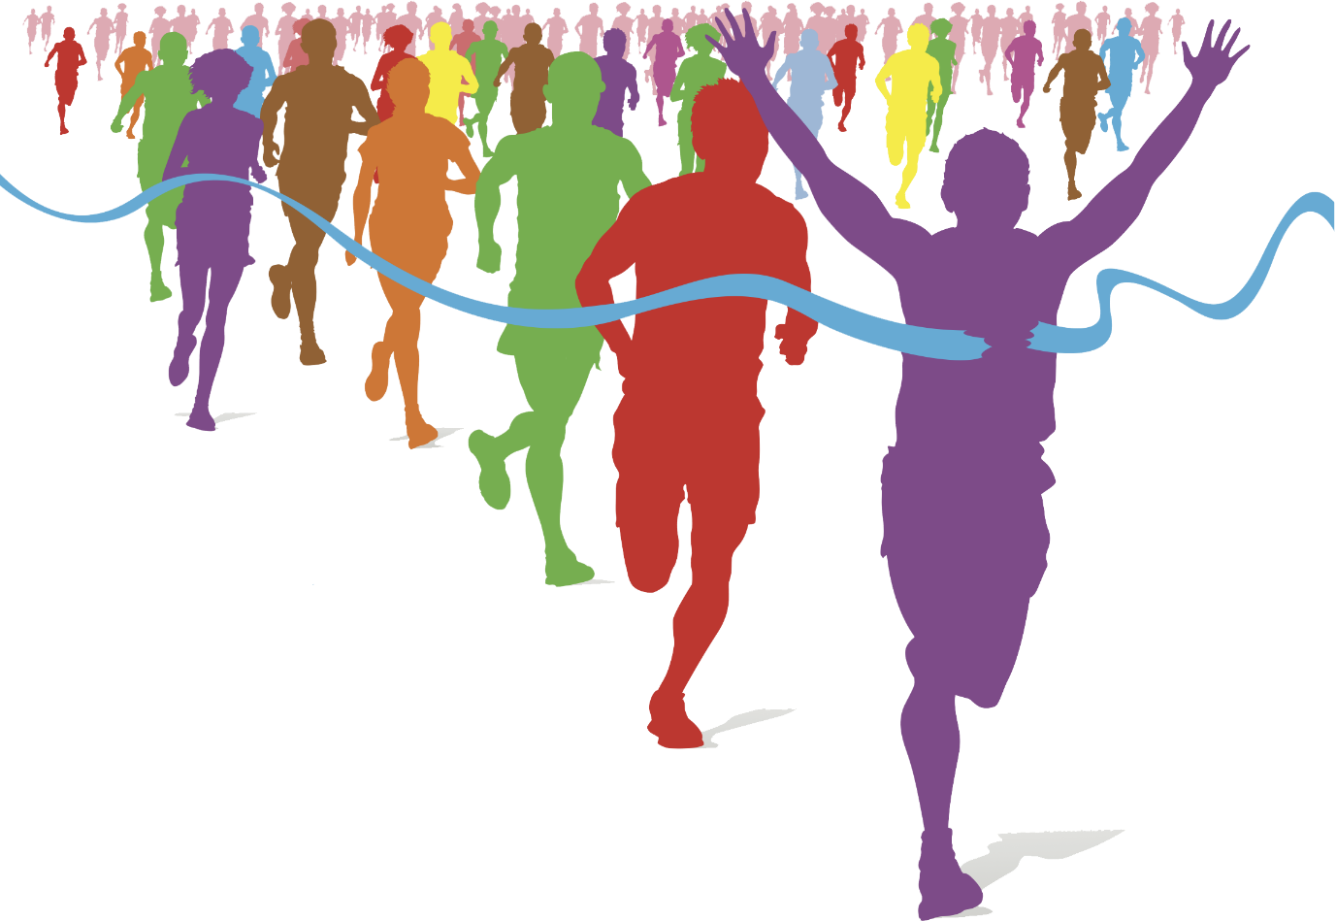

**A DEEP LEARNING AND IMAGE TEXT DETECTION PROJECT BY**

**CHELSEA FERNANDES, SHARON MATHEW AND JOSHUA FERNANDES**

Contents

1. Introduction 4

1.1 Description 4

1.2 Problem Formulation 4

1.3 Motivation 4

1.4 Proposed Solution 6

1.5 Scope of The Project 6

2. Review of Literature 7

2.1 Deep Learning-Based Racing Bib Number Detection And Recognition Using YOLO 7

2.2 CRNN based Jersey-Bib Number/Text Recognition in Sports and Marathon Images 7

2.3 Racing Bib Number Recognition Using Deep Learning 8

2.4 Automatic Number Plate Recognition System for Vehicle Identification Using Optical Character Recognition 9

3. System Analysis 10

3.1 Functional Requirements 10

3.1.1 Major functionalities associated with the user are: 10

3.1.2 Major functionalities associated with the system are as follows: 10

3.1.3 Interface Requirements: 10

3.1.4 Business Requirements: 11

3.2 Non Functional Requirements 11

3.2.1 Performance 11

3.2.2 Reliability 11

3.2.3 Usability 11

3.3 Specific Requirements 11

3.3.1  User Interfaces 11

3.3.2  Hardware Requirements 12

3.3.2  Software Requirements 12

3.3.3 Communication Interfaces 12

3.4 Use-Case Diagrams and Description 13

4. Analysis Modelling 16

4.1 Class Diagram and Activity Diagram 16

4.1.1 Class Diagram: 16

4.1.2 Activity Diagram: 17

4.2 Functional Modelling 18

5. Design 20

5.1 Architectural Design 20

5.2` User Interface Design 21

6. Implementation 24

6.1 Algorithms Used 24

6.1.1 OpenCV EAST Detector 24

6.1.2 Non Max Suppression 26

6.1.4 Prediction Filtering 27

6.2 Working of the project 28

6.3 Output 33

7. Conclusion 36

8. Acknowledgements 38

**Chapter 1**

# Introduction

## Description

In marathons, thousands of people run together making it difficult to keep track of each and every person manually. Generally, marathon runners are tracked when they cross a particular checkpoint and this tracking is done manually which is not always convenient. In this project, by using deep learning and image processing we aim to create a system which will identify and recognize Bib number associated with each marathon runner.  A bib is a sheet of paper that has a unique bib number, printed in big fonts, along with the runner’s name and some other text.  After identifying the Bib number from the pictures and videos, the system tags each picture with recognised text. Also, if a video of a marathon is uploaded, our system identifies bibs in each frame and  display and records information containing bib no.s as recognised by our system and all the information about the occurrence of a bib in the video in a downloadable file.

## Problem Formulation

A marathon managing agency wants to tag pictures of marathon with bib numbers and also be able to upload any videos of marathon and get information about occurrence of a bib in the video at a particular time.  In order to tag images and frames with bib no.s it is necessary to first recognise and identify the bib numbers occurring in the images. The task is to use appropriate machine learning or deep learning algorithms to recognise and identify bib numbers from the image. Prior to applying image text detection perform image preprocessing and text region detection for best results.

## 1.3 Motivation

Healthy lifestyle trends are getting more prominent around the world. there are numerous number of marathon running race events that have been held and inspired interest among peoples of different ages, genders and countries. Such diversified truths increase more difficulties to comprehend large numbers of marathon images, since such process is often done manually. Therefore, a new approach for racing bib number (RBN) detection and recognition for marathon running races using deep learning has been implemented by us. In our system, a person wanting to get the bib number associated with marathon runner from a marathon image can get it along with other information if it’s a video.

Though Bib number detection and recognition  in natural photographs is a hard problem due to the multiple sub-tasks that it entails : detecting and localizing the text, segmenting the text region and recognizing the characters. A few solutions have been implemented for this problem. The more recent development of deep learning algorithms for computer vision led a few researchers to tackle this problem from a different angle. For that reason, building efficient and fast deep learning algorithms has recently been a very active area of research. In this work, we propose to tackle the problem of recognizing and reading bib numbers using and end-to-end deep learning algorithm which can run smoothly on a consumer hardware.

They can upload a picture or video of a marathon and get all the bibs that occur in it specific to the marathons along with other information like occurrence of bib in a particular video in a downloadable file and thus do not have to go through the task of manual tagging and recording of bibs occurring in an image or video.  There are various methods to perform text detection in images like:

1. Segmentation using deep learning
2. Object Detection using deep learning
3. Face Recognition
4. Cloud-based APIs

The drawbacks in the above mentioned algorithms are that they are heavy on power and computationality  and detecting the runner's face. So we used EAST text detector along with Tesseract text recognition which gives better results with less complexity.

## 1.4 Proposed Solution

Dataset consists of images of marathon runners throughout the world. The images are in jpg, jpeg and png formats. The marathon runner is wearing a bib which has a unique identification number through which the participant can be tracked. For recognition in webcam and video files, the footage is broken down into frames and processed individually as images. The image or video is uploaded by the user along with file of all bib numbers that are expected to be detected. We used OpenCV EAST text detector to find the text regions from the image. Then we extracted only those results from EAST Detector which satisfies minimum confidence above a threshold. We applied non-max supression method which is used to combine overlapping detection. Then we cropped individual regions containing text from the image and ran each cropped region through pytesseract for text recognition. Finally we filter out the results based on bib format of the particular organisation and displayed result image with bounding box. For videos and webcam the time of occurence of the frame from which the bib number was detected was stored in an excel file along with status whether predicted or not. User can download this file to check the bibs that were detected along with time of occurrence.

## 1.5 Scope of The Project

Our system uses deep learning and image processing which will identify the Bib number associated with each marathon runner. It can prove to be of great convenience for the organizers. Generating reports of the marathons with thousands of participants will be made easier. The scope of the system is high as our system will help the organizers analyse the data from marathons better.

**Chapter 2**

# Review of Literature

## 2.1 Deep Learning-Based Racing Bib Number Detection And Recognition Using YOLO

**Authors:** Yan Chiew Wong, Li Jia Choi, Ranjit Singh Sarban Singh, Haoyu Zhang and A. R.Syafeeza

**Publication:** Jordanian Journal of Computers and Information Technology (JJCIT), Vol. 05, No. 03, December 2019.

**Approach:**

In order to deal with manual tagging of  large numbers of marathon images, a  new approach for  racing bib number (RBN) localization  and recognition  for marathon running races  using deep  learning was proposed  in  this paper. Previously, all RBN application systems have been developed by using image processing techniques only, which limits the performance achieved. There are two phases in the proposed system that are phase 1: RBN detection and phase 2: RBN recognition. In  phase 1, You Only Look Once version 3 (YOLOv3) which consists of a single convolutional network is used to predict the runner and RBN by multiple bounding boxes and class probabilities of those  boxes.YOLOv3 is a new  classifier network that  outperforms other  state-of-art networks.  In phase 2, Convolutional Recurrent Neural Network (CRNN) is used to generate a label sequence for each input image and then select  the label sequence that has the  highest probability. The developed  system is suitable for  marathon or  distance running race  events and automates the localization and recognition of racers, thereby increasing efficiency in event control and monitoring as well as post-processing the event data.

## 2.2 CRNN based Jersey-Bib Number/Text Recognition in Sports and Marathon Images

**Authors:** [Sauradip Nag](https://www.researchgate.net/profile/Sauradip_Nag), [R. Raghavendra](https://www.researchgate.net/profile/R_Raghavendra), [Palaiahnakote Shivakumara](https://www.researchgate.net/profile/Palaiahnakote_Shivakumara), [Mohan Kankanhalli](https://www.researchgate.net/scientific-contributions/2161730891_Mohan_Kankanhalli)

**Publications:  ICDAR 2019,  Australia**

**Approach:**

In this paper, to combat challenges with tracing of participants in sports through videos or  images, the authors propose  a new framework based on detecting the human body parts such that both Jersey Bib number and text is localized reliably. To achieve this, the proposed method first detects and localize the human in a given image using Single Shot Multibox Detector (SSD). In the next step, different human body parts namely, Torso, Left Thigh, Right Thigh, that generally contain a Bib number or text region is automatically extracted. These detected individual parts are processed individually to detect the Jersey Bib number/text using a deep CNN network based on the 2-channel architecture based on the novel adaptive weighting loss function. Finally, the detected text is cropped out and fed to a CNN-RNN based deep model abbreviated as CRNN for recognizing jersey/Bib/text.

## 2.3 Racing Bib Number Recognition Using Deep Learning

**Authors:** Erica Ivarsson, Roland M. Mueller

**Publication:** Proceedings of the 25th Americas Conference on Information Systems (AMCIS) At: Cancun, Mexico (Best Paper Nominee)

**Approach:**

Their research investigates the use of deep convolutional neural networks for racing bib number recognition in sport images. As labelled images of racing bib numbers are scarce, their paper investigates the potential benefits of transfer learning, by training models partly and fully on the Street View House Numbers (SVHN) dataset. Several deep neural network architectures were studied by them. The best recognition results were obtained by a model that had been trained on a hybrid dataset of the SVHN images plus an additional 262,131 images of racing bib numbers. Their results show that deep learning can effectively be used for racing bib number recognition. Also, the effectiveness of transfer learning for this problem is demonstrated in their paper.

## **2.4 Automatic Number Plate Recognition System for Vehicle Identification Using** Optical Character Recognition

**Authors:** [Muhammad Tahir Qadri](https://ieeexplore.ieee.org/author/37320522100) , [Muhammad Asif](https://ieeexplore.ieee.org/author/37658214100)

**Publications:** [2009 International Conference on Education Technology and Computer](https://ieeexplore.ieee.org/xpl/conhome/5169431/proceeding) by IEEE

**Approach:**

Here, in this approach they have implemented Automatic number plate recognition (ANPR) which is an image processing technology which uses number (license) plate to identify the vehicle. Their objective is to design an efficient automatic authorized vehicle identification system by using the vehicle number plate. The system is implemented on the entrance for security control of a highly restricted area like military zones or area around top government offices e.g. Parliament, Supreme Court etc. The developed system first detects the vehicle and then captures the vehicle image. Vehicle number plate region is extracted using the image segmentation in an image. Optical character recognition technique is used for the character recognition.  It is observed from the results that the developed system successfully detects and recognizes the vehicle number plate on real images using image text detection methods such as OCR.

**Chapter 3**

# System Analysis

## 3.1 Functional Requirements

### 3.1.1 Major functionalities associated with the user are:

* Enables the user to register and then login to the system
* Enables user to select from the navigation bar the desired function (upload image, video or webcam) the user would like to perform.
* It allows user to select an image / video from which the text has to be detected.
* A user can upload a csv file which contains the bib numbers of the participants along with the video or in the webcam page, to check if the bib numbers are predicted correctly.

### 3.1.2 Major functionalities associated with the system are as follows:

* The system extracts images from a particular frame of a video, then preprocess the image.
* The system then uses OpenCV EAST Text Detector to find regions of text.
* Then it crops the image and passes this cropped image through pytesseract for text recognition
* It finds out the predictions according to bib format and displays desired output.

### 3.1.3 Interface Requirements:

* Requires backend and frontend software to create a user friendly system.
* Windows is required for communication interface.

### 3.1.4 Business Requirements:

* By uploading a video to the system it automatically detects the bib numbers, which reduces the work of manually detecting the bib no. of the participant.

## 3.2 Non Functional Requirements

### 3.2.1 Performance

The computer running the software must have a powerful CPU and GPU so that the data can be processed faster and there won’t be lag in the entire process of detecting the bib no. The system might take a little longer to predict text from a video, has it takes time to process the video.

### 3.2.2 Reliability

The system takes in the input in the form of an image or video and detects the Bib no. accurately if the input is clear for the system to understand. There is a small chance for the system to might predict the text incorrectly.

### 3.2.3 Usability

The system is easy to handle and helps in detecting the bib no. easily. The system interacts with the user in a very friendly manner making it easier for the users to use the system.

## 3.3 Specific Requirements

### 3.3.1  User Interfaces

The software provides a good graphical user interface. The user can register or login into the system. The user can upload an image / video or can use a webcam by selecting on the options given. Based on the selected option, the output is displayed on the interface.

* Front-end Software: HTML, CSS,Web browser.
* Back-end Software: Pycharm

### 3.3.2  Hardware Requirements

* Operating system: Windows
* Hard disk: 40 GB and above
* RAM size: 256 MB and above
* Processor: Pentium(R) Dual-core CPU
* Working keyboard
* CPU Type : Intel i3 and above
* Clock speed : 2.1 GHz

### 3.3.2  Software Requirements

* Operating System : Windows
* Python
* Webpage(Using HTML, CSS, Bootstrap)

### 3.3.3 Communication Interfaces

* Windows

## 3.4 Use-Case Diagrams and Description

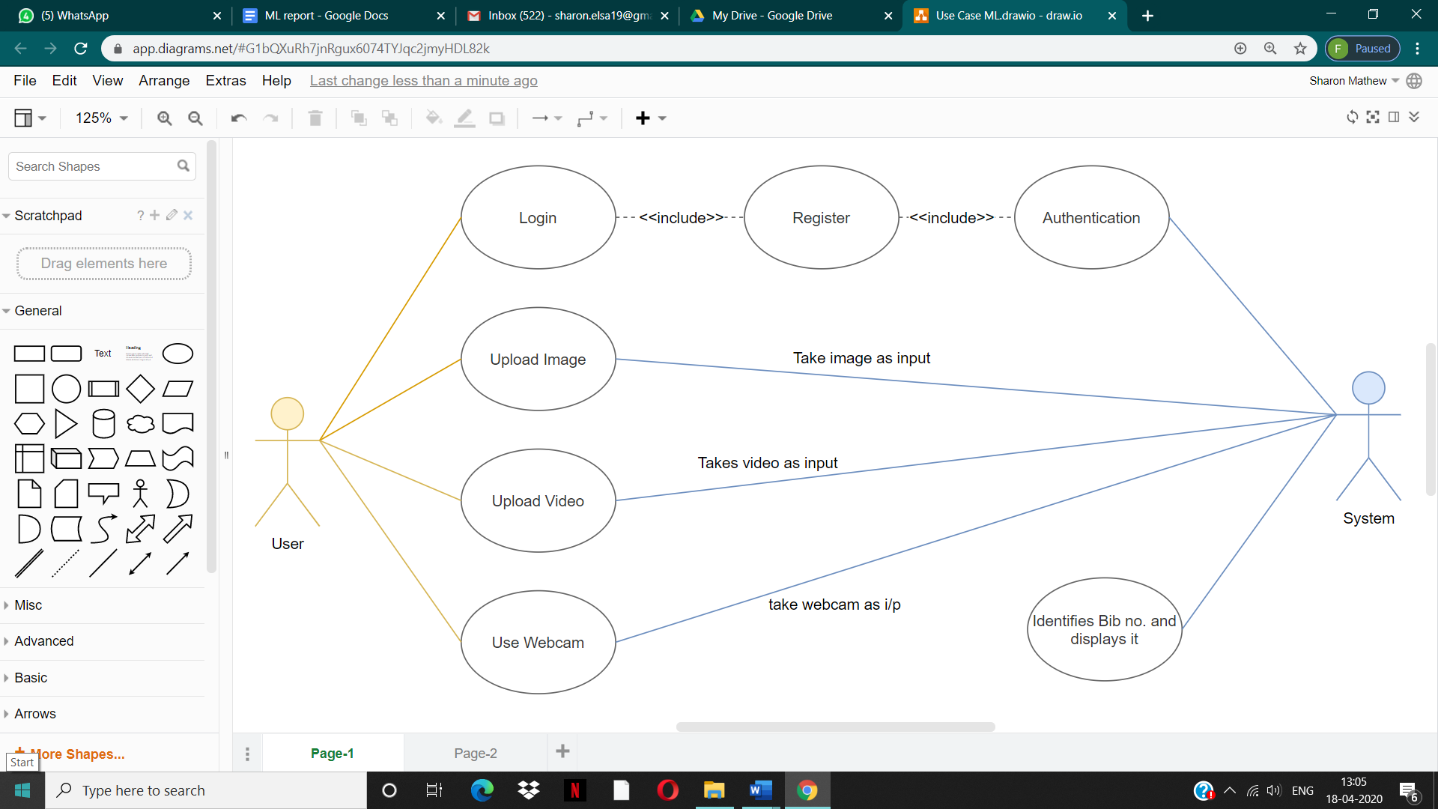

Fig No.1 : Use Case Diagram

**Use Case Diagram :**

Use Case Diagram captures the system's functionality and requirements by using actors and use cases. Use Cases model the services, tasks, function that a system needs to perform. A Use Case consists of use cases, persons, or various things that are invoking the features called as actors and the elements that are responsible for implementing the use cases. Use case diagrams capture the dynamic behaviour of a live system. It models how an external entity interacts with the system to make it work.

**Use Case Specification:**

1. **Actor : User**
2. **Function :** Login

* **Brief Description :** The user can login to the system with the username and password
* **Main Flow :**
* The user is asked to login to the system using the username and password.
* If the user does not have an account, then he can register through the signup page.

1. **Function :** Upload Image

* **Brief Description :** The user should upload an image which contains bib no., for the system to recognize the text in that image
* **Main Flow :**
* The user can choose an image file from which bib no. has to be detected and the upload the file using the ‘upload’ button.
* This will take the user to a new web page which will show the image that is uploaded along with the text detected.

1. **Function :** Upload Video

* **Brief Description :** The user can upload a video from which bib no. has to be recognized.
* **Main Flow :**
* The user can click on the ‘Video’ link provided in the navigation bar to upload a video.
* The user is asked to choose a video and a csv file which contains the bib no.

1. **Function :** Use Webcam

* **Brief Description :** By clicking on the webcam button the user gets access to the webcam
* **Main Flow :**
* The user can click on the ‘Webcam’ link provided in the navigation bar
* The user is a csv file which contains the bib no.
* Then the user can click on the webcam button to c=access webcam.

1. **Actor : System**
2. **Function :** Authentication

* **Brief Description :** The system verifies if the user has registered into the system database.
* **Main Flow :**
* The system verifies if the user entered username and password is present in the database system.
* If not present the user is not allowed to login.

1. **Function :** Input

* **Brief Description :** The system takes input (image/video) from user
* **Main Flow :**
* The system takes input in the form of video or an image or from webcam.
* It then identifies the bib no. from the input

1. **Function :** Identifies bib no. and displays it

* **Brief Description :** The system recognizes the bib no. from the input and the displays them.
* **Main Flow :**
* The system identifies the bib no. the displays them in the success web page.
* For video and webcam input, it also provides an excel sheet which tells if a bib no. is identified or no.

**Chapter 4**

# Analysis Modelling

## 4.1 Class Diagram and Activity Diagram

### 4.1.1 Class Diagram:

Class diagram is a static diagram. Class diagram is not only used for visualizing, describing, and documenting different aspects of a system but also for constructing executable code of the software application.

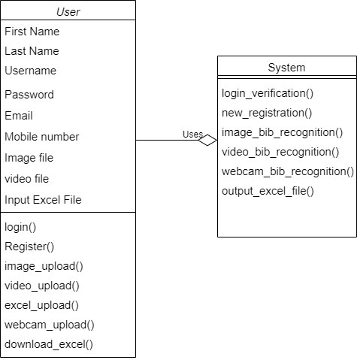

Fig No.2 : Class diagram

### 4.1.2 Activity Diagram:

Activity Diagrams describe how activities are coordinated to provide a service which can be at different levels of abstraction.

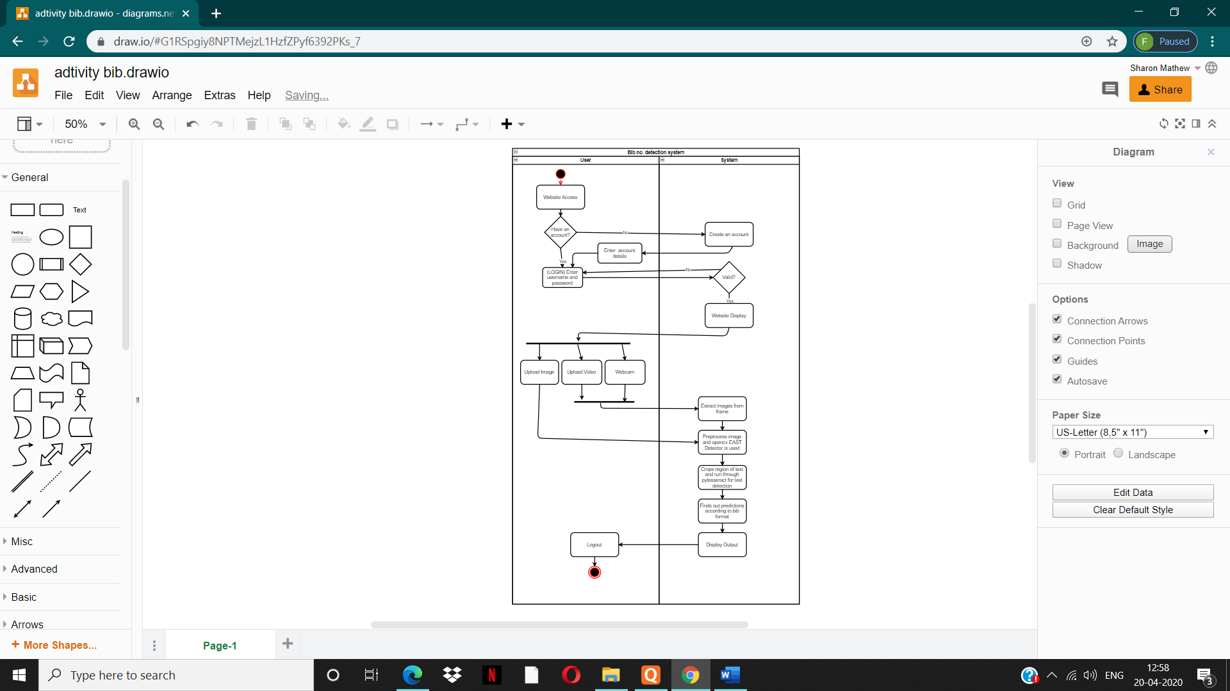

Fig No. 3: Activity diagram

## 4.2 Functional Modelling

**Data Flow Diagram**

Data flow diagrams are used to graphically represent the flow of data in a business information system. DFD describes the processes that are involved in a system to transfer data from the input to the file storage and reports generation

**Context Level DFD (Level 0  ):**

This Level is the Context Level DFD.  It is a basic overview of the whole system or process being analyzed or modelled. The user uploads an image or a video, from which the system recognizes the text and identifies it.

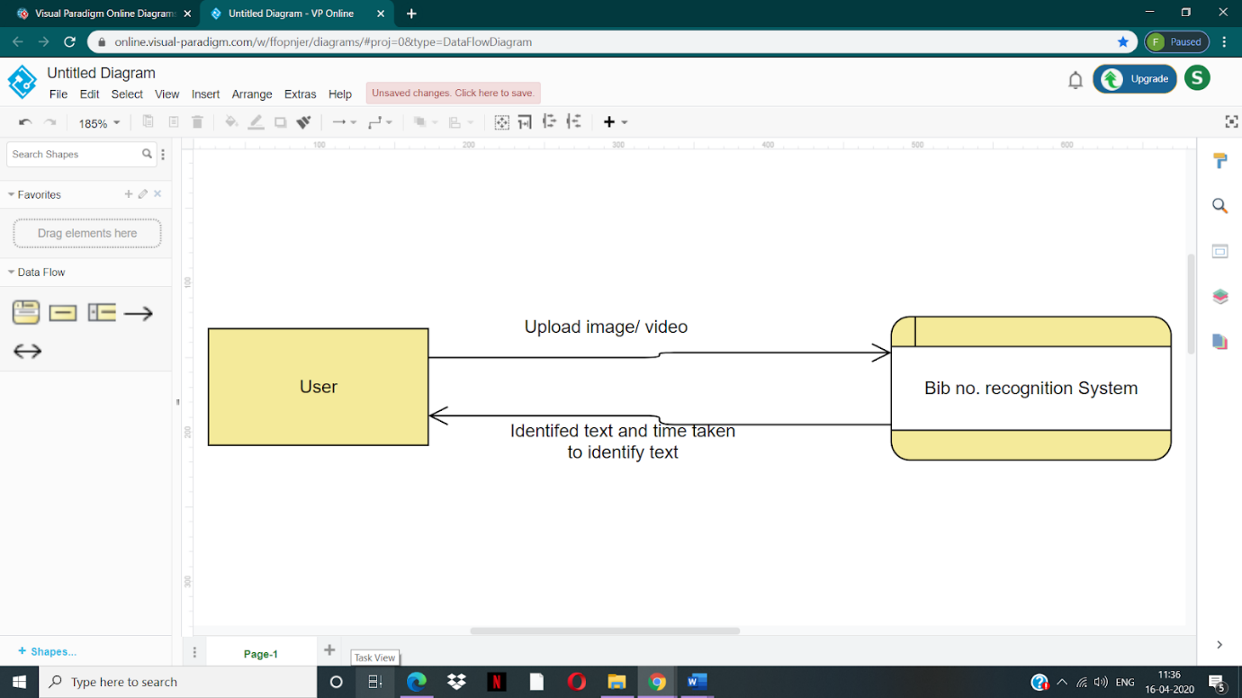

Fig No.4 : Context Level DFD

**Level 1 DFD:**

In 1-level DFD, context diagram is decomposed into multiple bubbles/processes.in this level we highlight the main functions of the system and break down the high level process of 0-level DFD into sub processes.

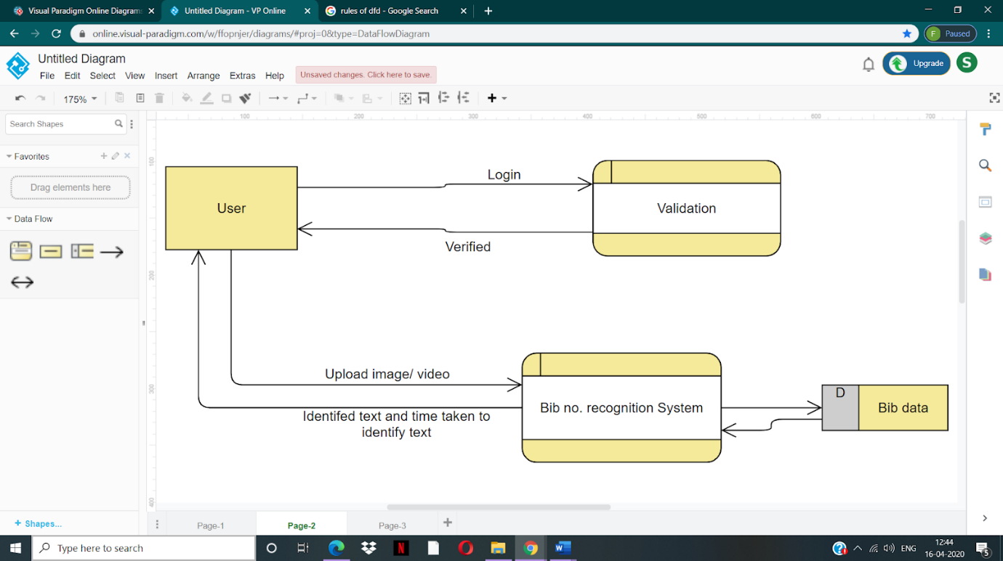

Fig No.5 : Level 1 DFD

**Level 2 DFD:**

A 2-level DFD goes one step deeper into parts of 1-level DFD. It can be used to plan or record the specific/necessary detail about the system’s functioning.

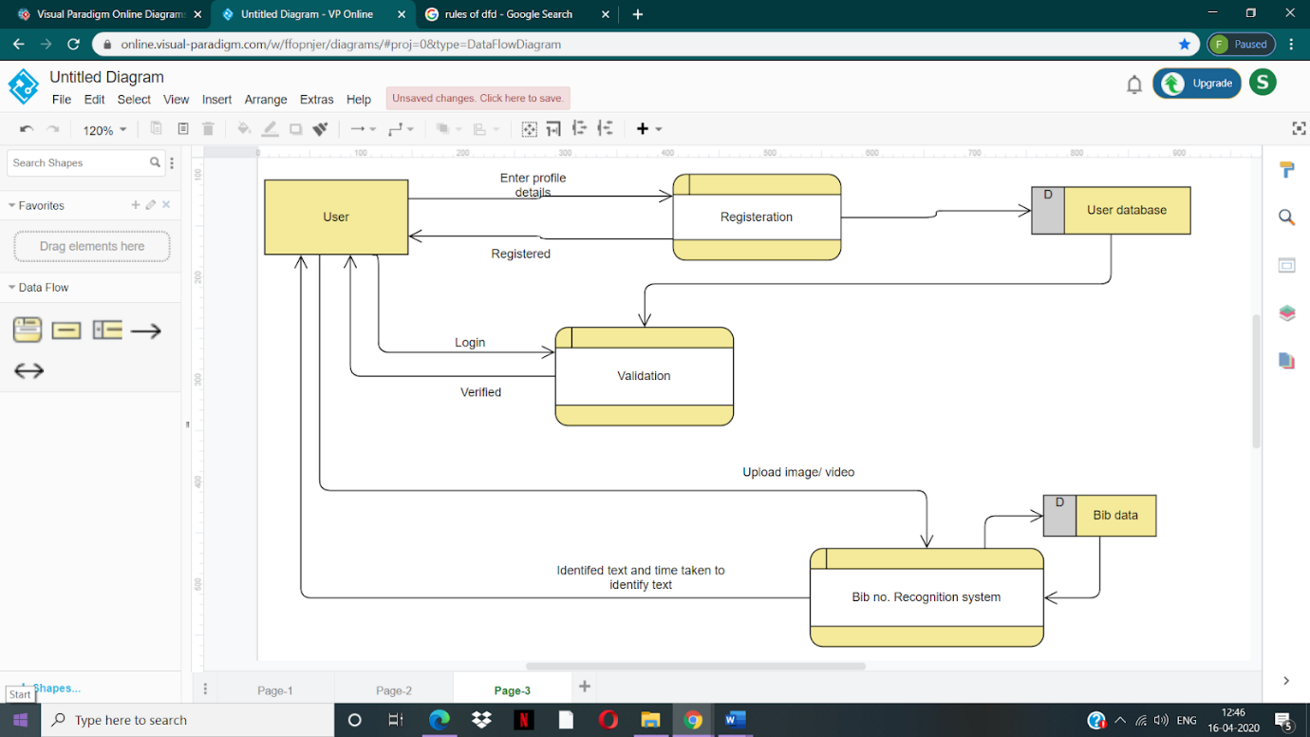

Fig No.6 : Level 2 DFD

**Chapter 5**

# Design

## 5.1 Architectural Design

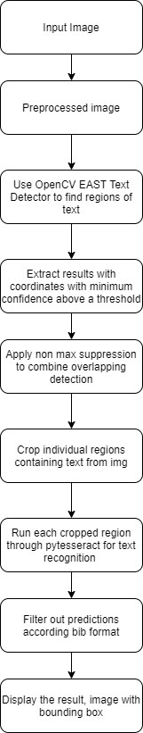

Fig No.7 : Architectural diagram / work flow of the system

## 5.2` User Interface Design

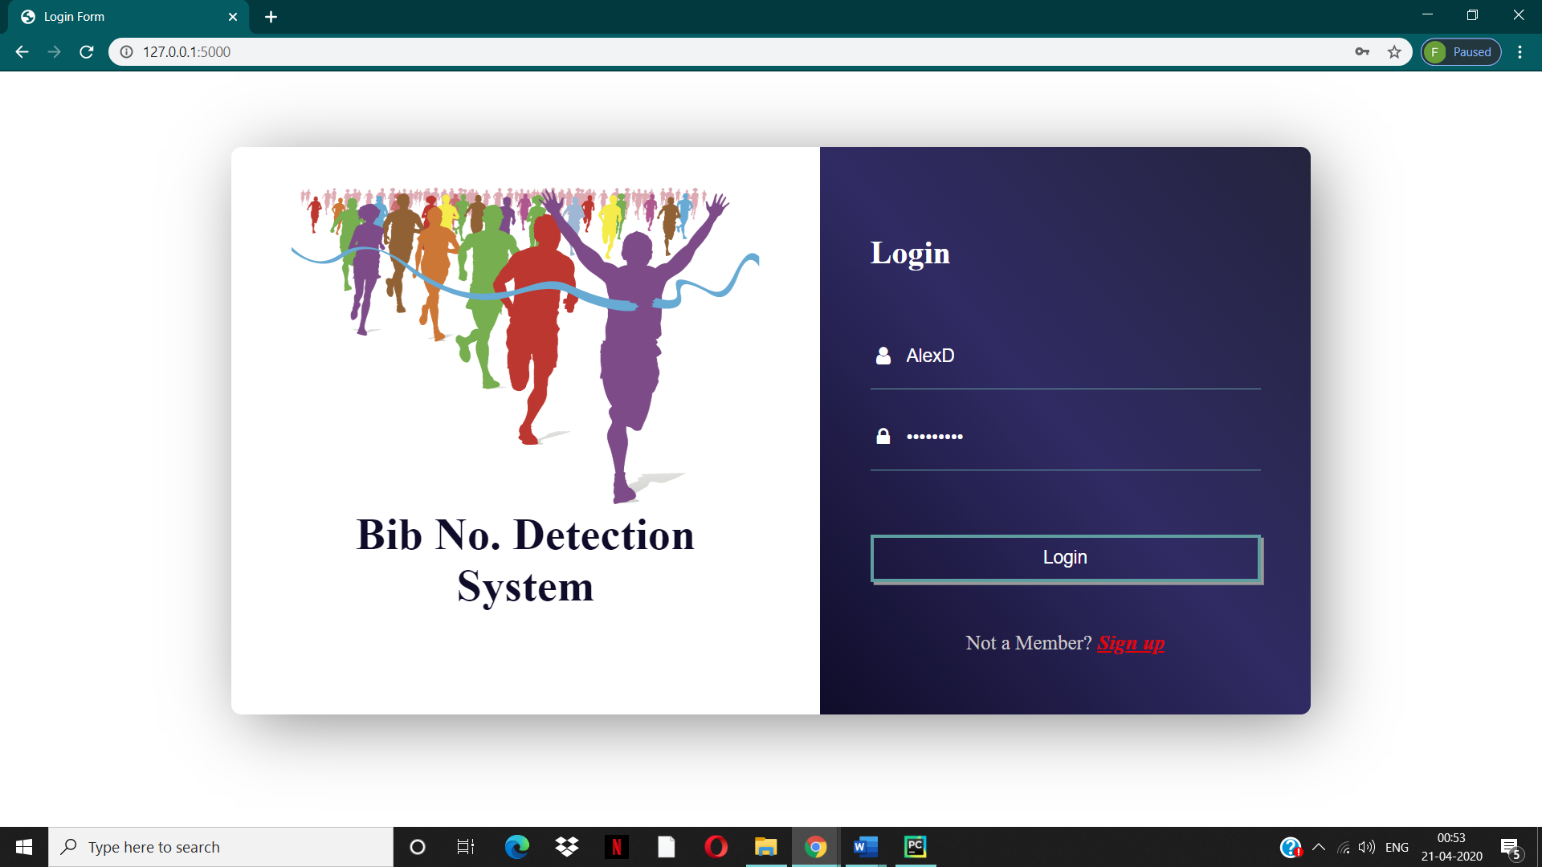

Fig No.8 : Login page



Fig No.9 : Sign Up page/ Registration page

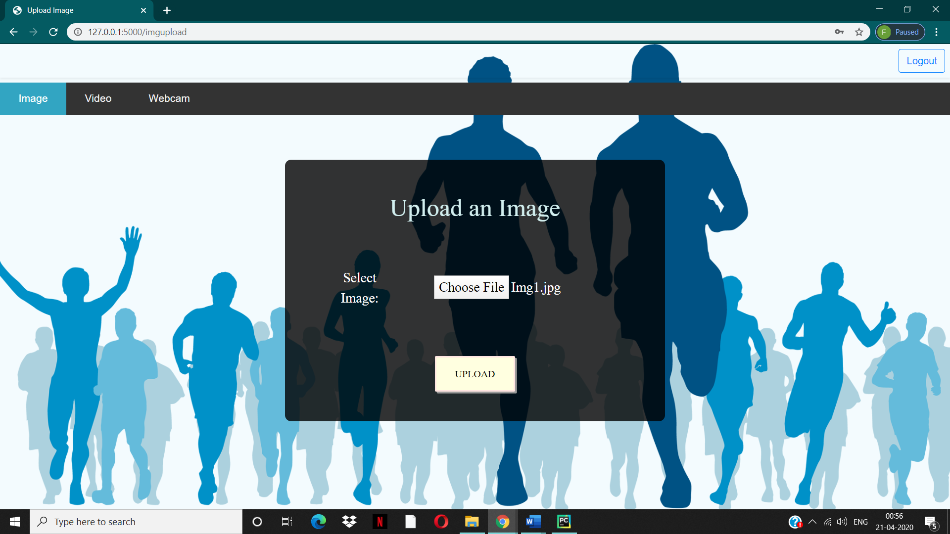

Fig No.10 : Image uplaod

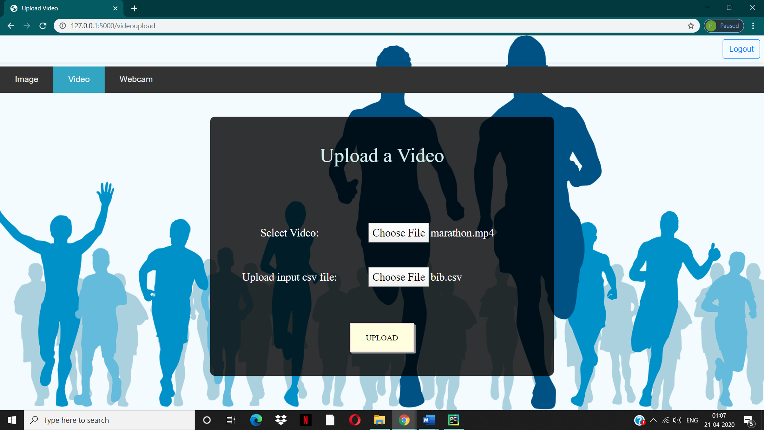

Fig No.11 : Video upload

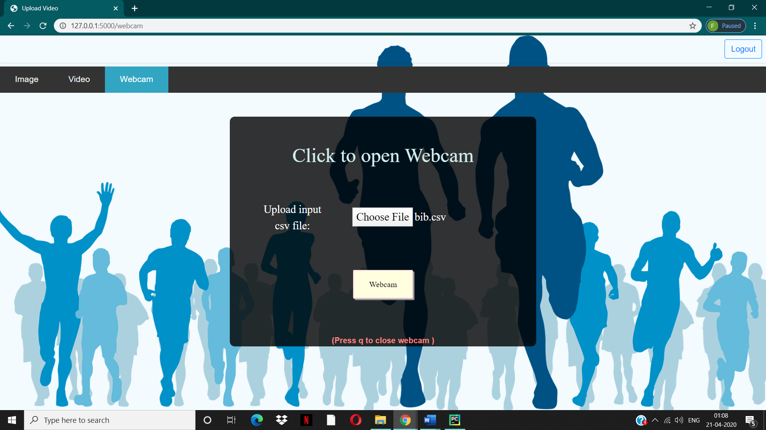

Fig No.12 : Webcam

**Chapter 6**

# Implementation

## 6.1 Algorithms Used

### 6.1.1 OpenCV EAST Detector

**Feature Extraction**

In OpenCV EAST Detector, the first step is feature extraction which uses the VGG16 model which is a Convolutional Neural Network which extracts the various features present hidden in images.

The model is trained on extracting TEXT data present in images of various sizes.

Through OpenCV, we use a deep learning-based text detector called EAST, which is based on Zhou et al.’s 2017 paper, [***EAST: An Efficient and Accurate Scene Text Detector***](https://arxiv.org/abs/1704.03155).

**1. Feature Extractor Stem**

This branch of the network is used to extract features from different layers of the pretrained network VGG16. it takes the output from the VGG16 model after pool2, pool3, pool4, and pool5 layers.

**2. Feature Merging Branch**

In this branch of the EAST network, it merges the feature outputs from a different layer of the VGG16 network. EAST uses a U-net architecture to merge feature maps gradually. Out[uts are concatenated to produce the final feature map layer before the output layer.

**3. Output Layer**

The output layer consists of a score map and a geometry map. The score map tells us the probability of text in that region while the geometry map defines the boundary of the text box.

The model outputs scores and geometry of text regions detected in the image. Following this images are filtered according to a min-confidences threshold and finally Non-Max supression is applied.

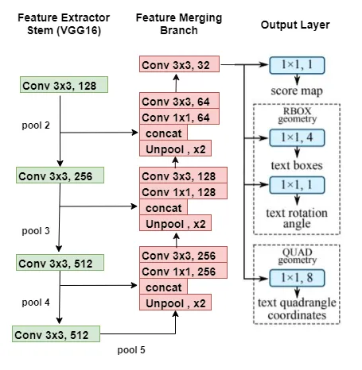

Fig No.13 : Feature Extraction

### 6.1.2 Non Max Suppression

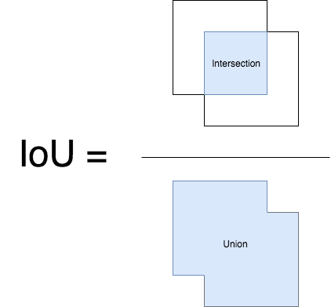NMS is used to make sure that in object detection, a particular object is identified only once. We apply non-maximum suppression to ignore bounding boxes that significantly overlap each other.

→ It first discards all those cells where probability of object being present (calculated in final softmax layer) is <= Threshold

→ Then it takes the cell with largest probability among candidates for object as a prediction

→ Finally we discard any remaining cell with Intersection over union value >= 0.5 with the prediction cell.

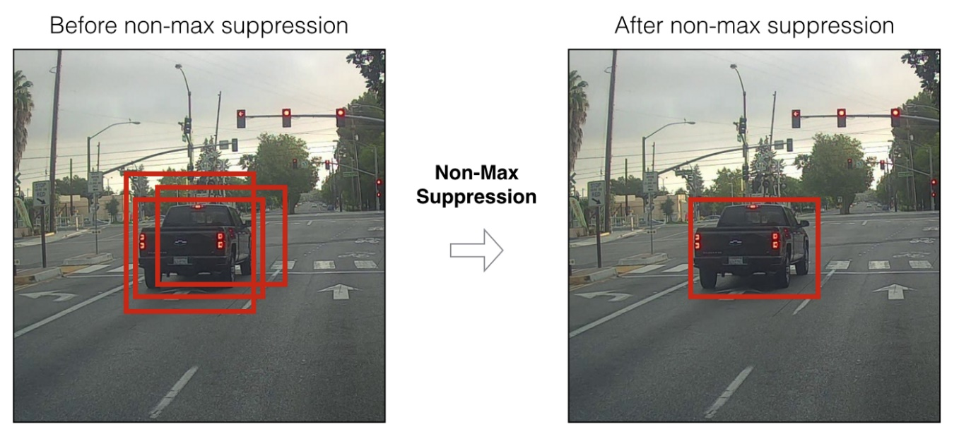

Fig No.14 : Non Max Suppression

**6.1.3 Tesseract OCR using pytesseract**

OCR = Optical Character Recognition. In other words, OCR systems transform a two-dimensional image of text, that could contain machine printed or handwritten text from its image representation into machine-readable text.We use Py-Tesseract library to implement Tesseract.

Tesseract has unicode (UTF-8) support, and can recognize more than 100 languages. Legacy Tesseract 3.x was dependant on the multi-stage process where we can differentiate steps:

* Word finding
* Line finding
* Character classification

Modernization of the Tesseract tool was an effort on code cleaning and adding a new LSTM model. The input image is processed in boxes (rectangle) line by line feeding into the LSTM model and giving output.



Fig No.15 : Result obtained from Tesseract OCR using pytesseract

### 6.1.4 Prediction Filtering

If text recognition is implemented directly without preprocessing the image then the are not accurate. The images come with a lot of disturbances such as other texts surrounding the BIB such us on Tshirts, sign boards, etc. Thus to be specific one can define a **regular expression** specific to the BIB numbers to filter out the other texts.

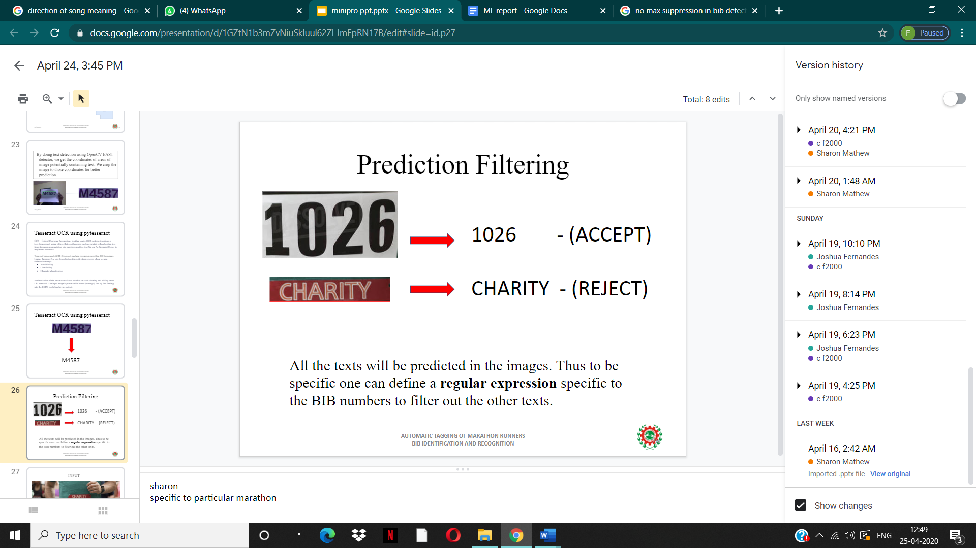

Fig No.16 : Prediction Filtering

## 6.2 Working of the project

Importing the libraries

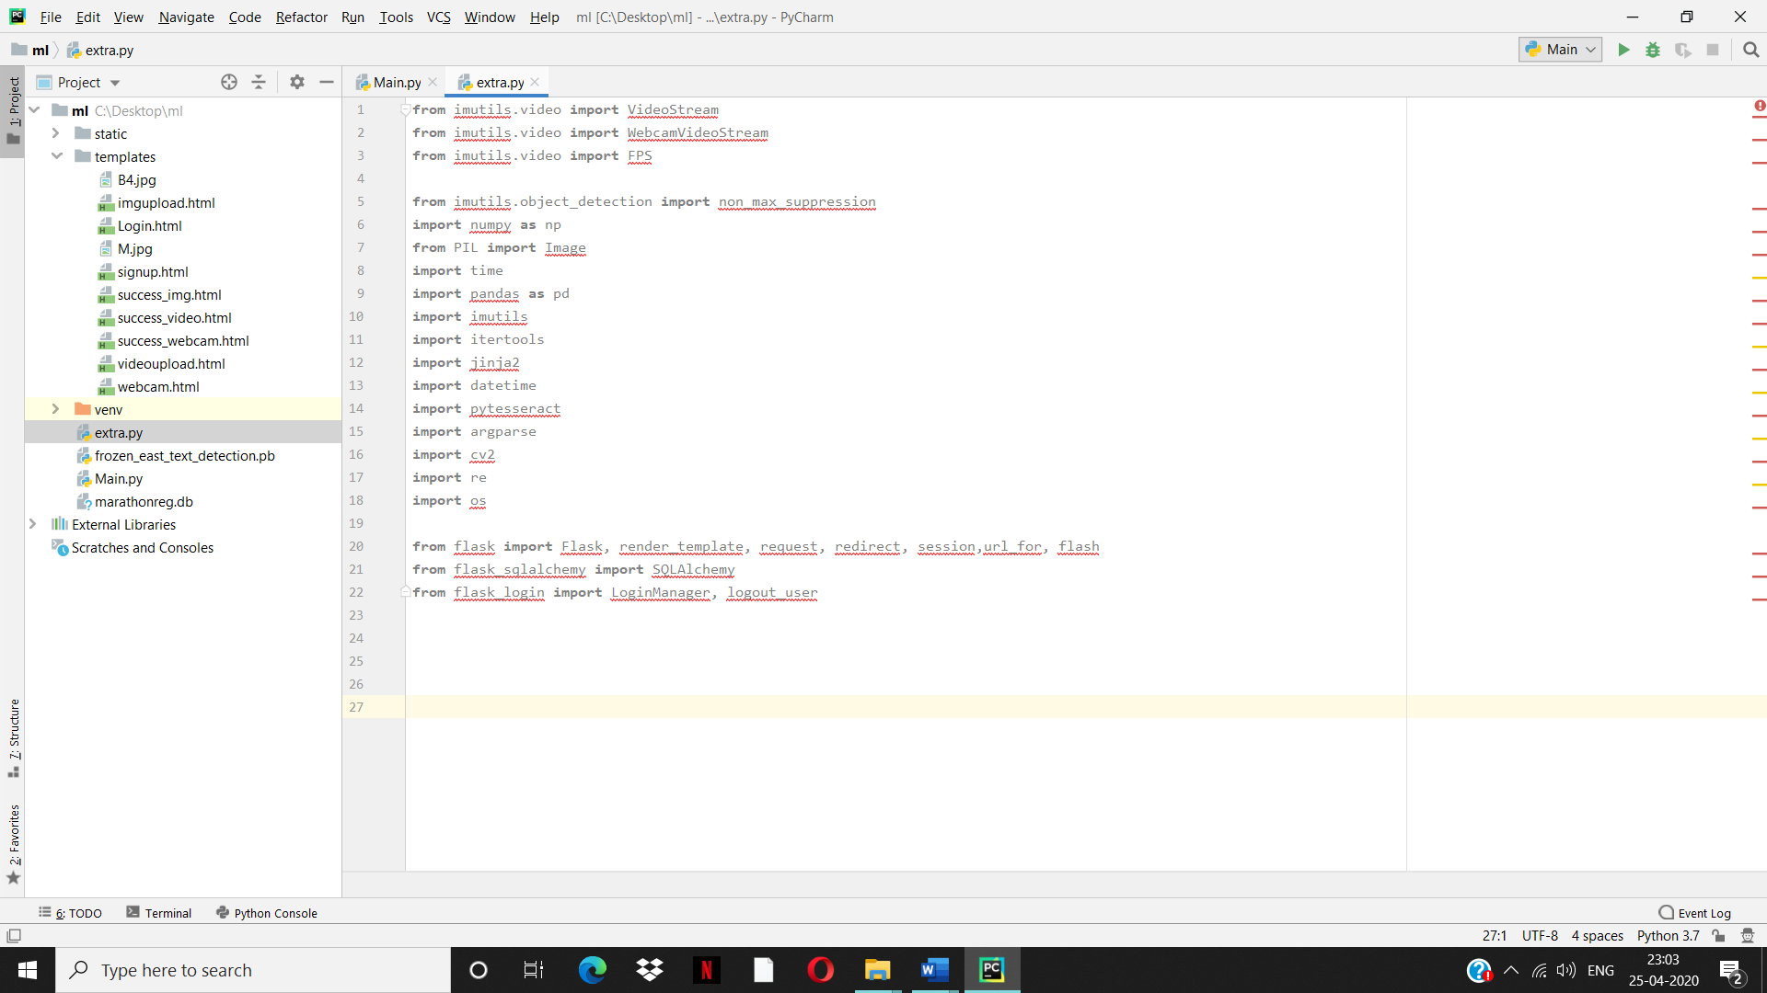

To save the uploaded video in folder

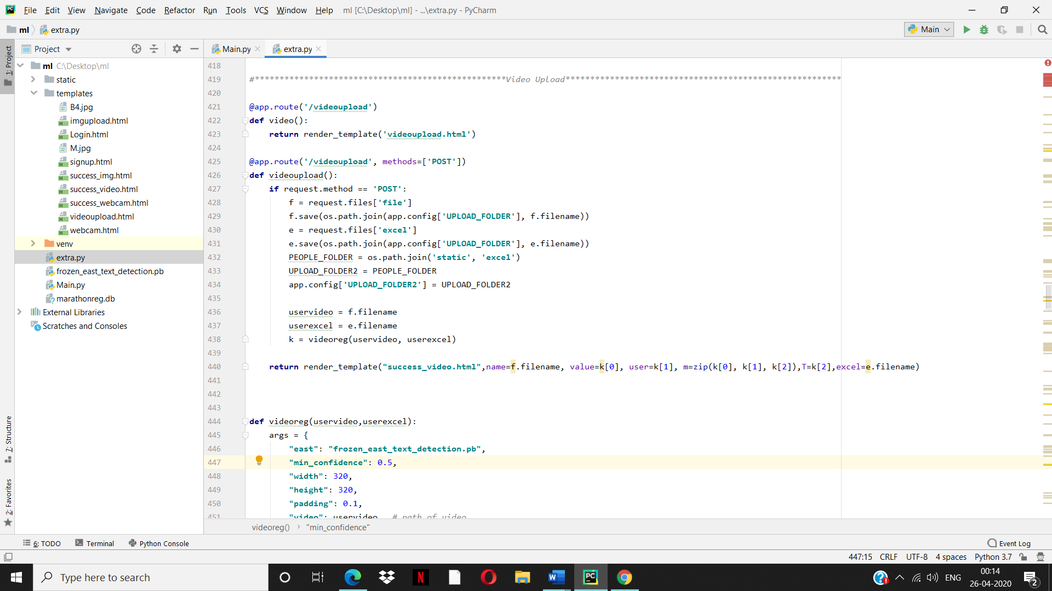

Passing the video and csv file for further processing



To obtain different frames from a video



Using of pytesseract and resizing of the image



To print predicted text

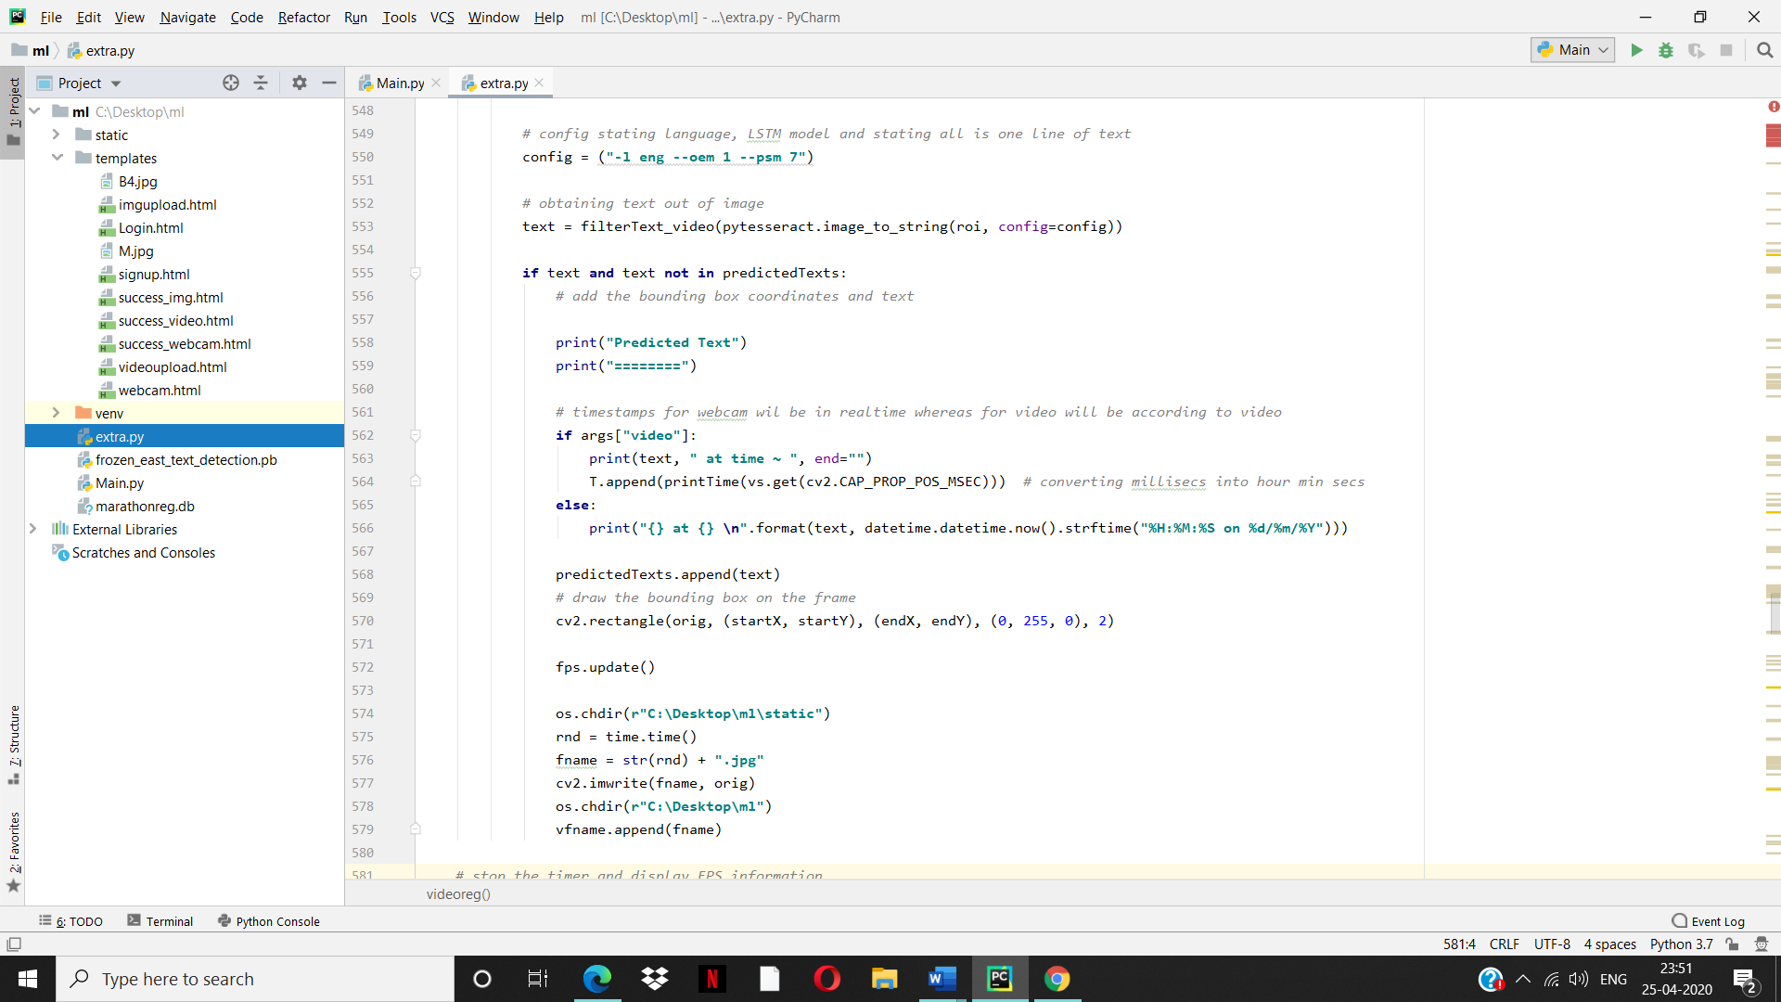

To stop timer and display FPS information

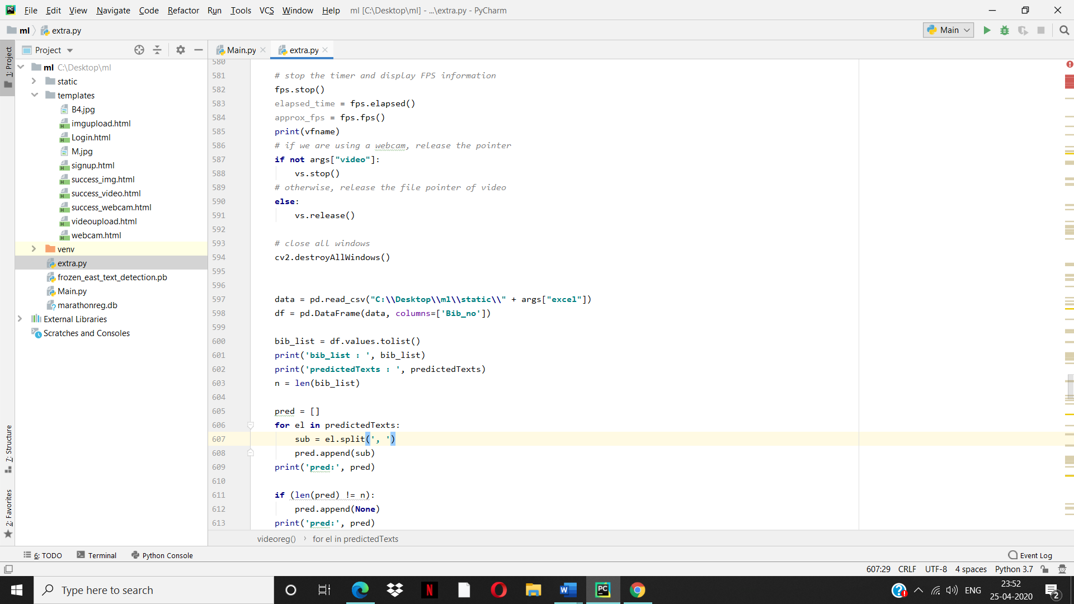

To store Status of bib numbers in excel sheet

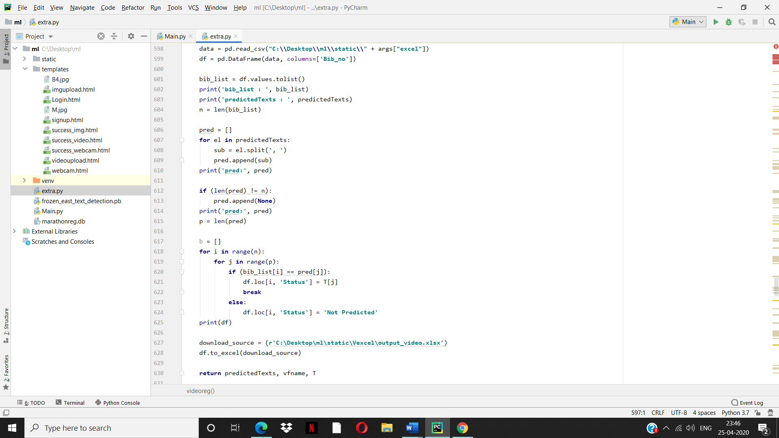

To decode the predictions

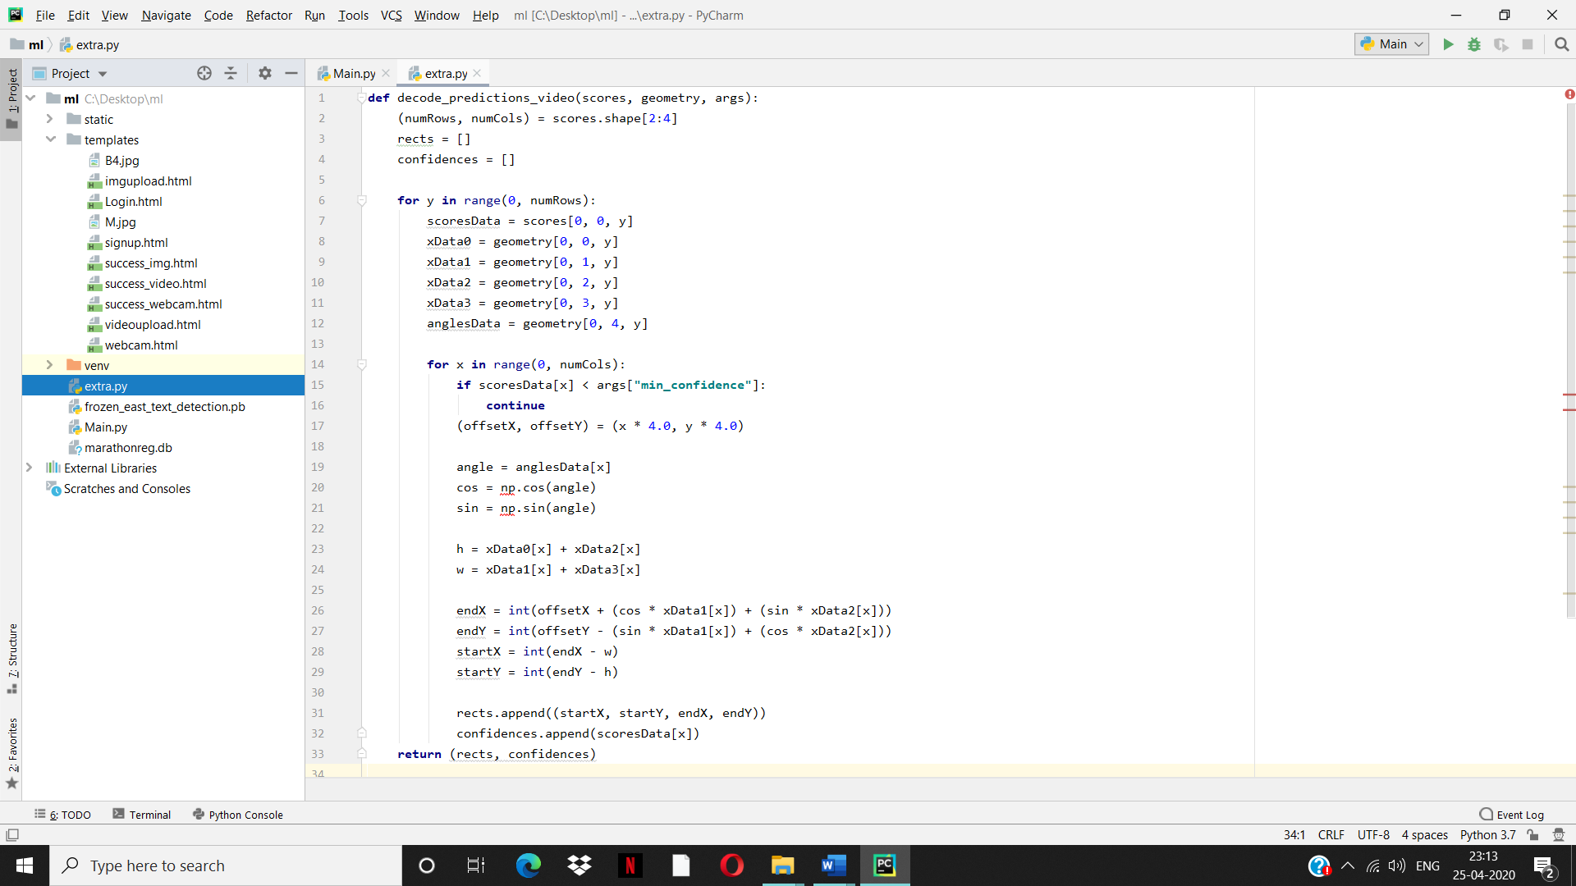

Filtering of text using regular expression

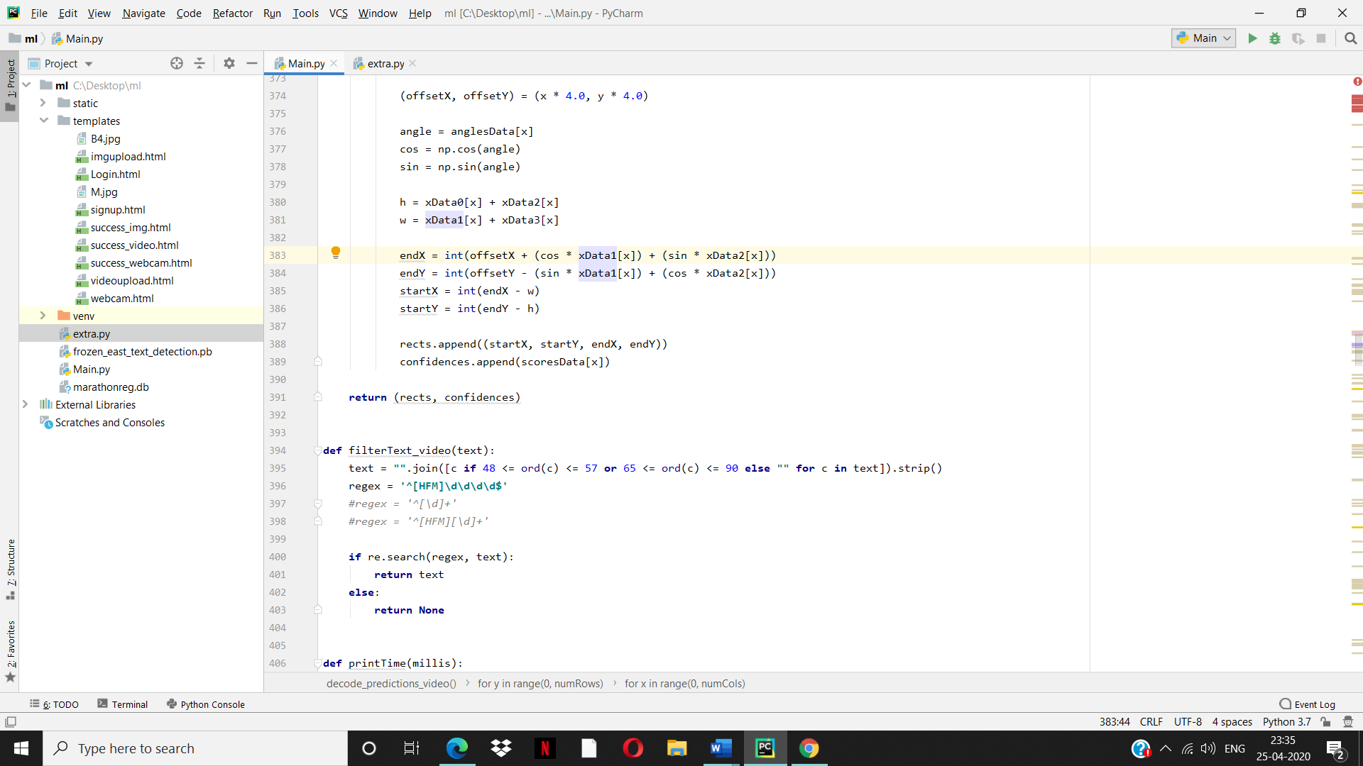

To find out time when a text is detected

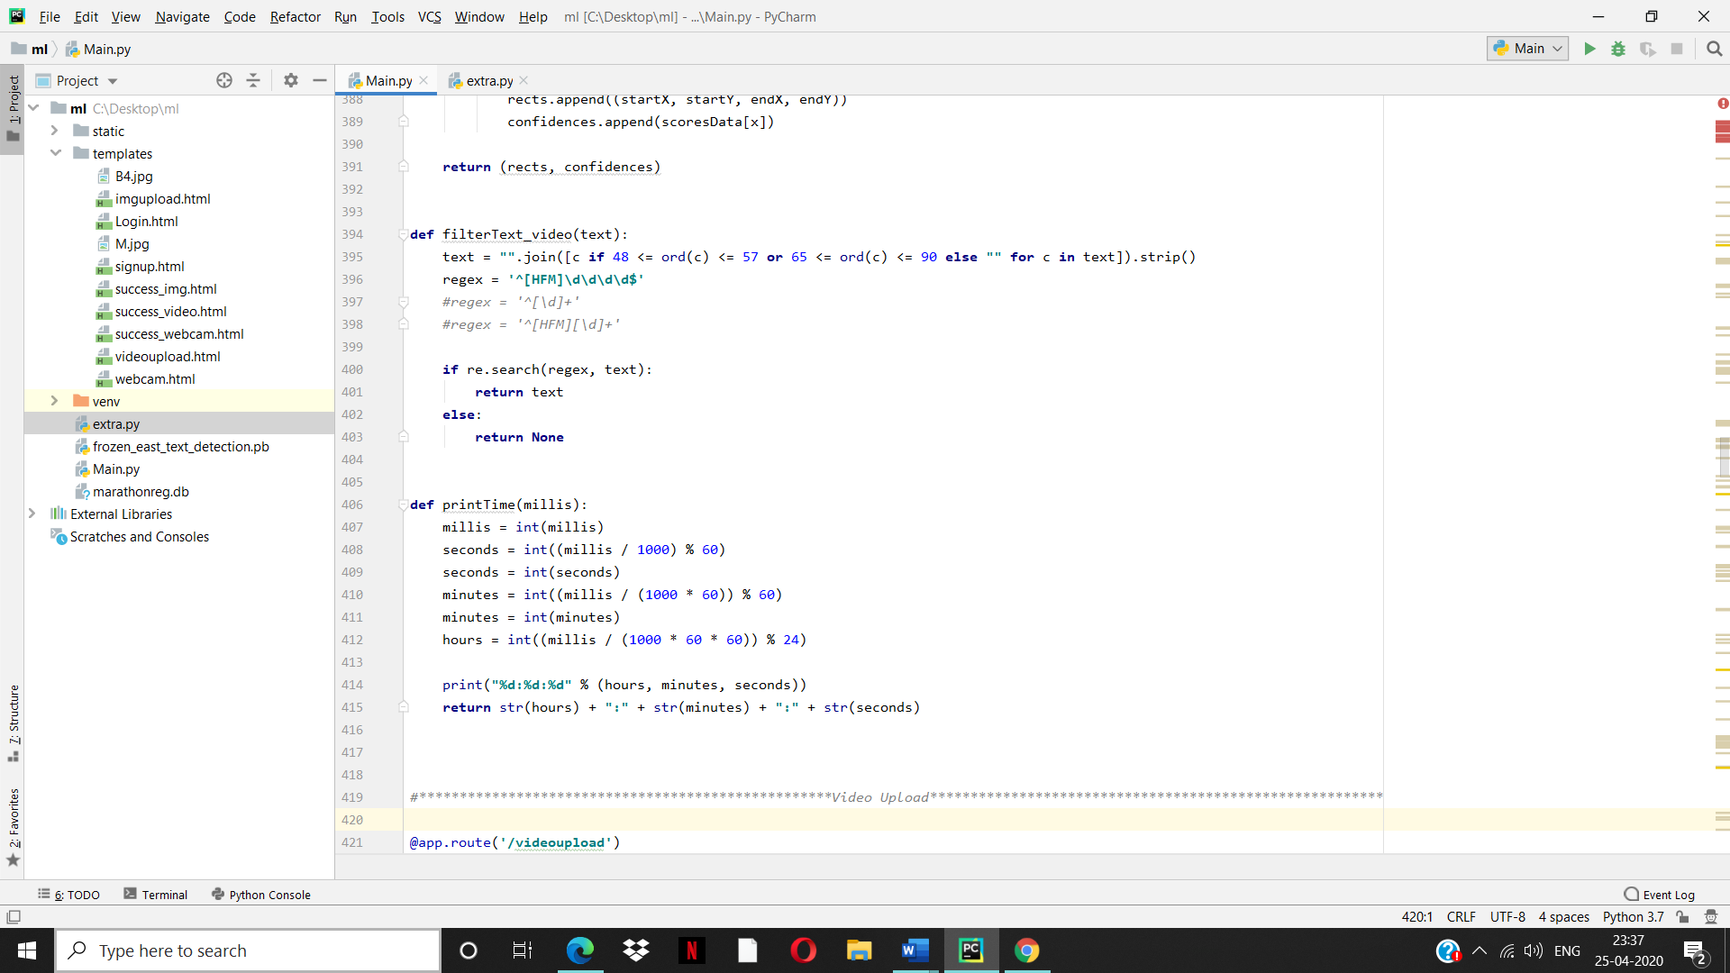

## 6.3 Output

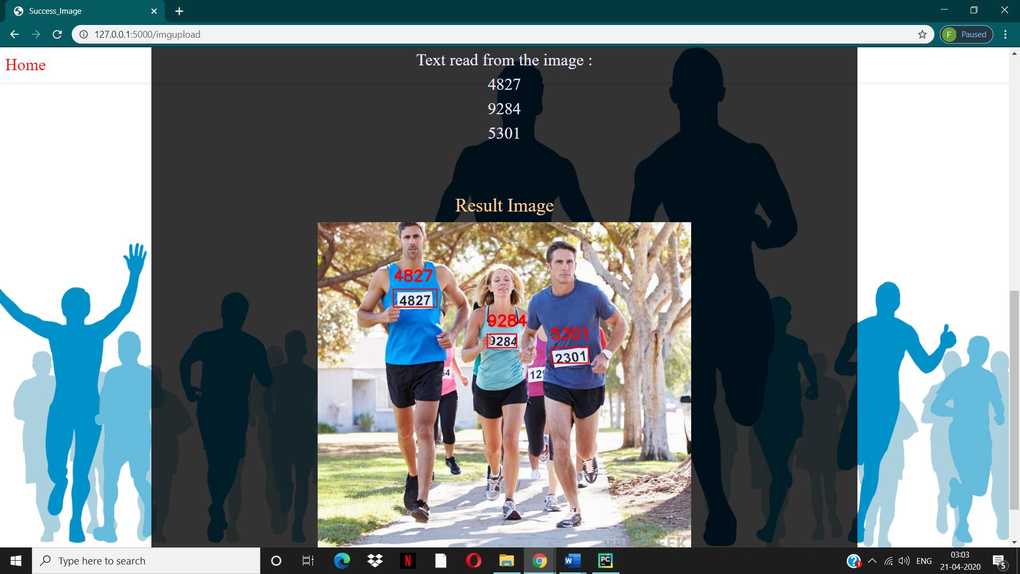

Fig No.17 : Result of Image upload

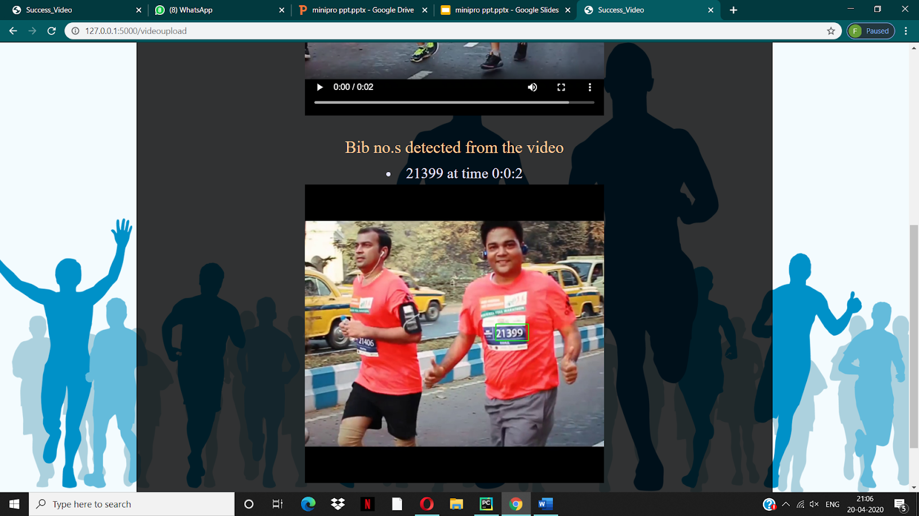

Fig No.18 : Result of Video upload

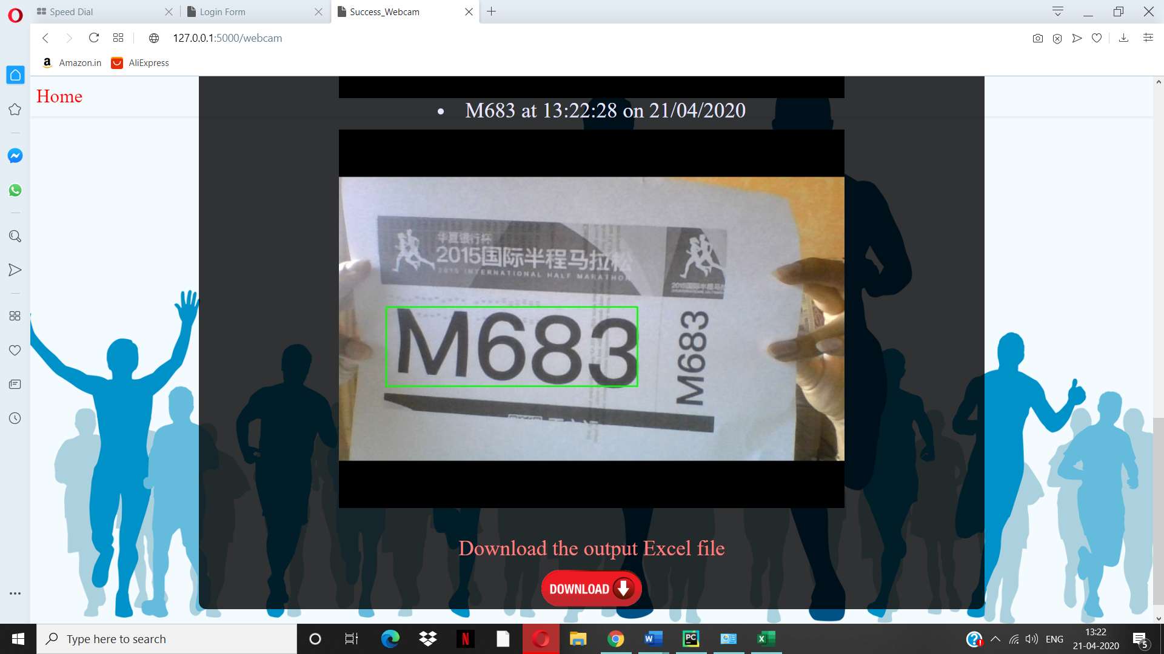

Fig No.19 : Result of Webcam



Fig No.20 : Output Excel file

**Chapter 7**

# Conclusion

The system was able to recognize and locate the text/bib no. position in the images and videos. With the help of this system manually noting of the bib number from videos is reduced. The algorithm was also tested for a no. of images and videos and the performance was satisfactory. The system does not give completely accurate results if the image is blurry or if there are many texts and text-like-shape that will lead to false predictions.

Future work is to find out new methods or techniques to filter out these unwanted texts as much as possible. Face detection method can also be purposed to the system to improve the accuracy and performance of the system.

**References**

* EAST: An Efficient and Accurate Scene Text Detector :

<https://arxiv.org/abs/1704.03155>

* TextBlob :

<https://www.pyimagesearch.com/2017/11/06/deep-learning-opencvs-blobfromimage-works/>

* Research Paper on Racing Bib number recognition:

<https://www.researchgate.net/publication/264853913_Racing_Bib_Number_Recognition>

* Blog on Marathon Bib Identification and Recognition:

<https://towardsdatascience.com/marathon-bib-identification-and-recognition-25ee7e08d118>

* Natural Scene Text Understanding by Celine Mancas-Thillou and Bernard

Gosselin in their 2017 paper:

<https://www.tcts.fpms.ac.be/publications/regpapers/2007/VS_cmtbg2007.pdf>

# Acknowledgements

We take the opportunity to thank all those people who have helped and guided us through this project and make this experience worthwhile for us. We wish to sincerely thank our reverend **Bro. Jose Thuruthiyil** and principal **Dr. Sincy George** for giving us this opportunity for making this project. We would also like to thank HOD of Computer department **Dr. Kavita Sonawane** and all teaching and non teaching staff for their immense support and cooperation.

Last but not the least we would like to thank **Mrs. G. Anuradha** for guiding us throughout the project and encouraging us to explore in this domain.